# Department of Computing

# database systems

# Course Instructor: Dr. shams qazi

# Lab 09

## **CS220: DB Systems**

## **Name: Mahum Samar**

# **CMS ID : 290647**

## **BSCS-9B**

# Write correlated-nested SQL expressions for each of the following queries and execute them:

Find the names of all juniors (Level = JR) who are enrolled in a class taught by ‘Ivana Teach’.

### Query:

SELECT sname, snum

FROM uni.student s

WHERE EXISTS( SELECT e.snum

FROM uni.enrollment e

WHERE EXISTS( SELECT c.cname

FROM uni.class c, uni.faculty f

WHERE c.cname = e.cname

AND f.fid = c.fid

AND f.fname = 'Ivana Teach'

AND s.level = 'JR'

AND s.snum = e.snum));

### Output:

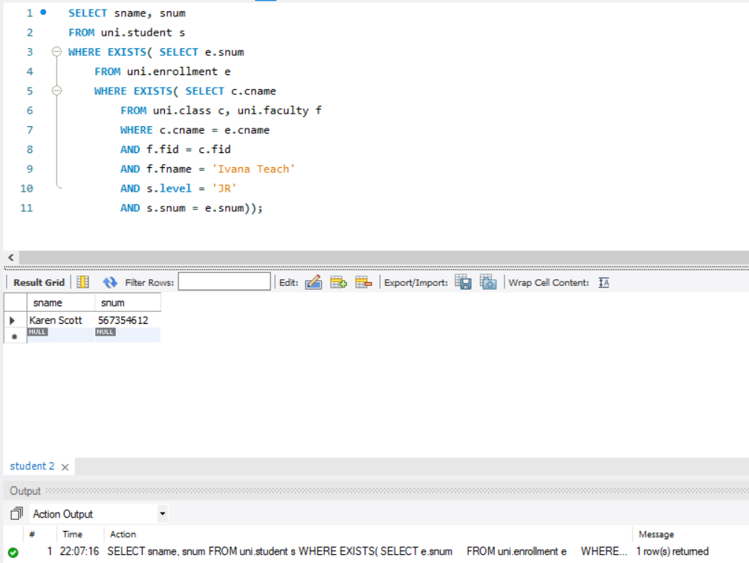

Find the names of faculty members that have taught classes only in room R128.

### Query:

SELECT f.fid, fname

FROM uni.faculty f, uni.class cl

WHERE NOT EXISTS(SELECT c.fid

FROM uni.class c

WHERE EXISTS(SELECT c.fid

WHERE c.fid = f.fid

AND NOT c.room = 'R128'))

AND cl.fid = f.fid;

### Output:

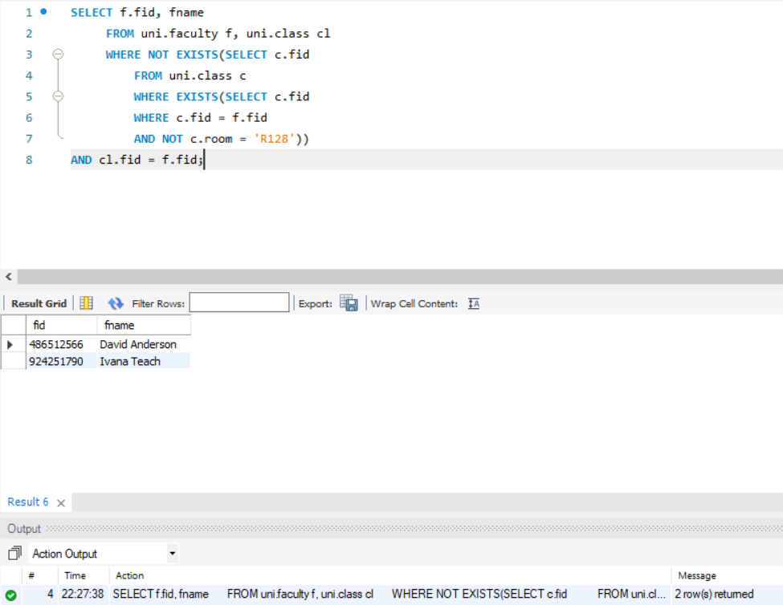

Find the names of classes taught by ‘Richard Jackson’ and their times when a class meet there.

### Query:

SELECT c.cname, c.meets_at FROM uni.class c

WHERE EXISTS(SELECT c.fid FROM uni.faculty f

WHERE f.fid = c.fid

AND fname = 'Richard Jackson');

### Output:

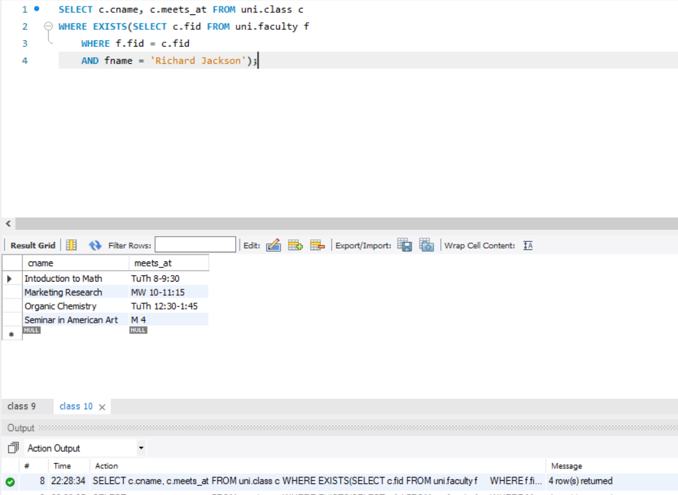

Retrieve the snum and sname of students who have taken classes from both ‘Ivana Teach’ and ‘Linda Davis’.

### Query:

SELECT s.snum, s.sname FROM uni.student s, (SELECT s.sname, s.snum FROM uni.student s

WHERE EXISTS(SELECT e.snum FROM uni.enrollment e

WHERE EXISTS (SELECT c.cname FROM uni.class c

WHERE EXISTS(SELECT f.fid FROM uni.faculty f

WHERE s.snum = e.snum

AND e.cname = c.cname

AND c.fid = f.fid

AND f.fname = 'Ivana Teach')))) AS IT INNER JOIN (SELECT s.sname, s.snum FROM uni.student s

WHERE EXISTS(SELECT e.snum FROM uni.enrollment e

WHERE EXISTS (SELECT c.cname FROM uni.class c

WHERE EXISTS(SELECT f.fid FROM uni.faculty f

WHERE s.snum = e.snum

AND e.cname = c.cname

AND c.fid = f.fid

AND f.fname = 'Linda davis')))) AS LD ON IT.snum = LD.snum;

### Output:

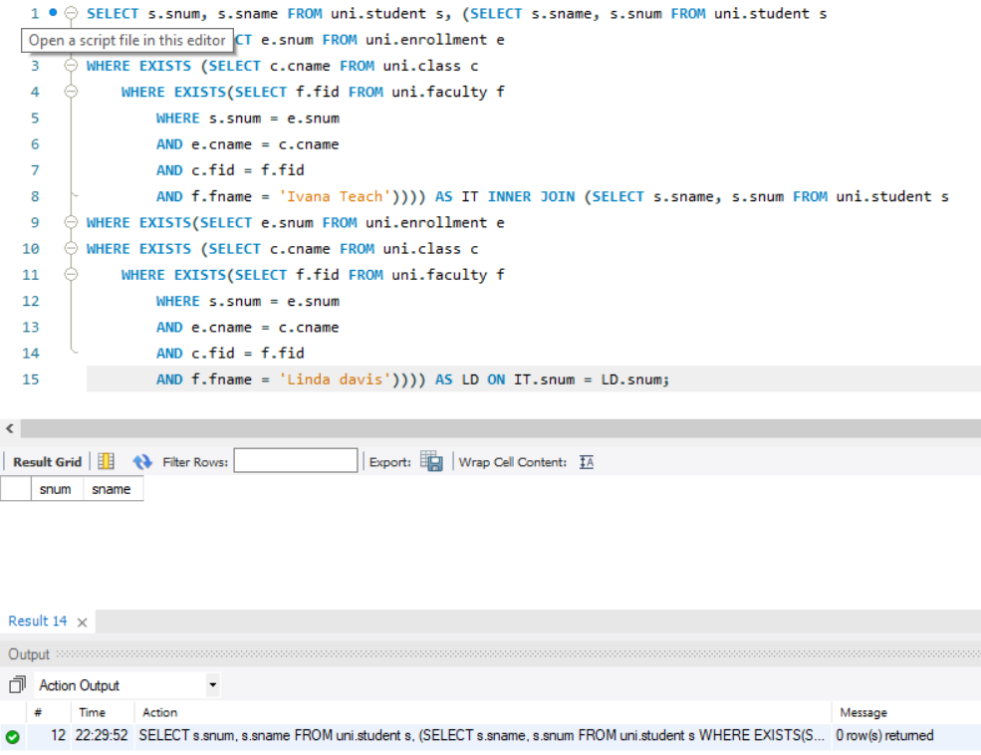

Find the age of the oldest students who is enrolled in a course taught by Ivana. Teach.

### Query:

SELECT MAX(age) AS maximumAge FROM uni.student s

WHERE EXISTS(SELECT e.snum FROM uni.enrollment e

WHERE EXISTS (SELECT c.cname FROM uni.class c

WHERE EXISTS(SELECT f.fid FROM uni.faculty f

WHERE s.snum = e.snum

AND e.cname = c.cname

AND c.fid = f.fid

AND f.fname = 'Ivana Teach')));

### Output:

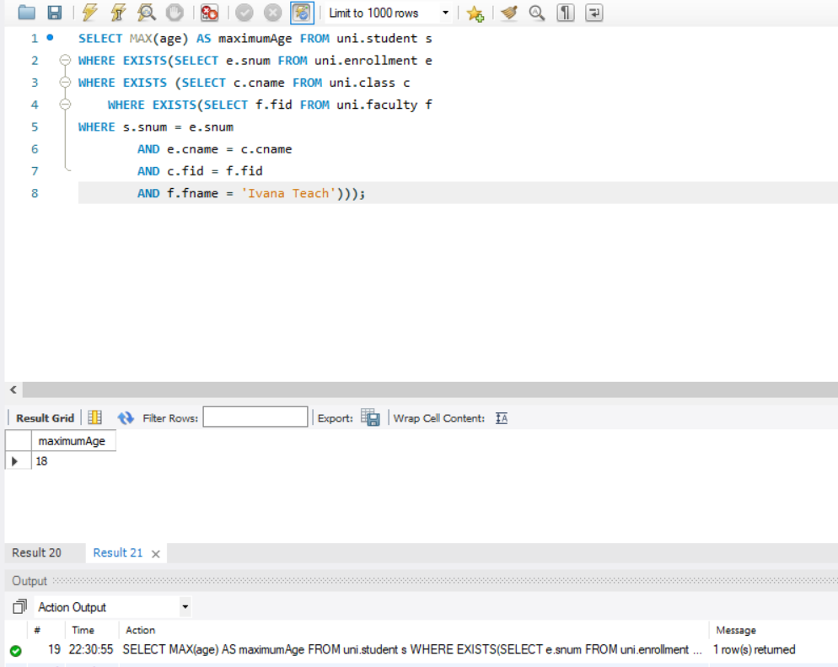

Find ages of students in ‘Database Systems’ class that are older than 20 years.

### Query:

SELECT DISTINCT age FROM uni.student s

WHERE EXISTS(SELECT e.snum FROM uni.enrollment e

WHERE s.snum = e.snum

AND e.cname = 'database systems'

AND age > 20);

### Output:

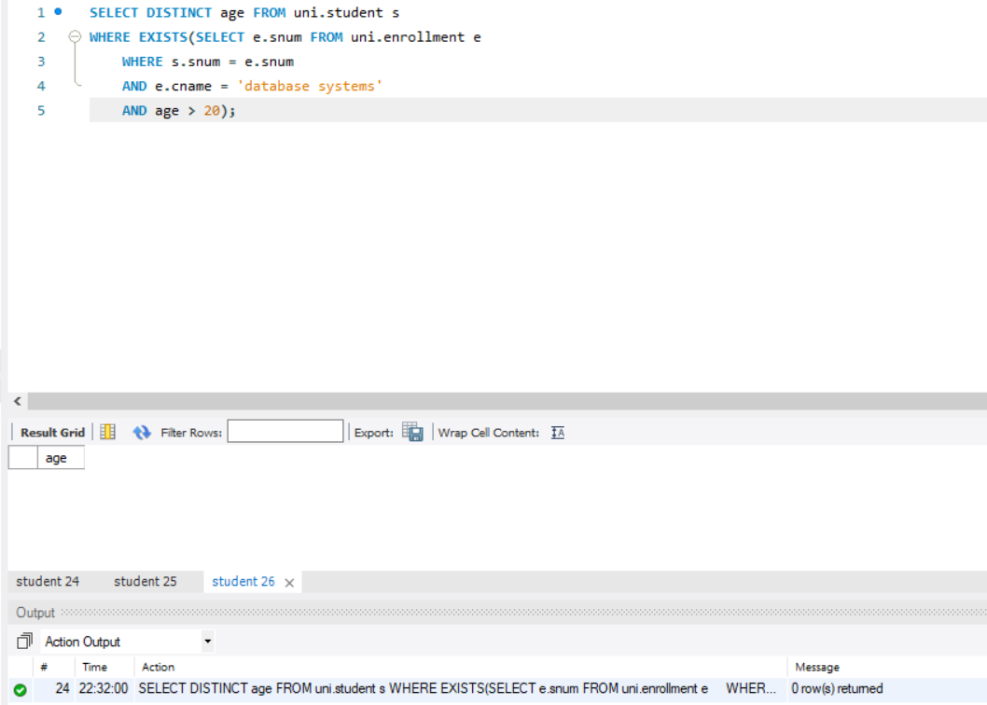

Find the name of faculty members that do not teach to class ‘database Systems’.

### Query:

SELECT f.fname FROM uni.faculty f

WHERE NOT EXISTS(SELECT c.fid FROM uni.class c WHERE

c.fid = f.fid

AND c.cname = 'database systems');

### Output:

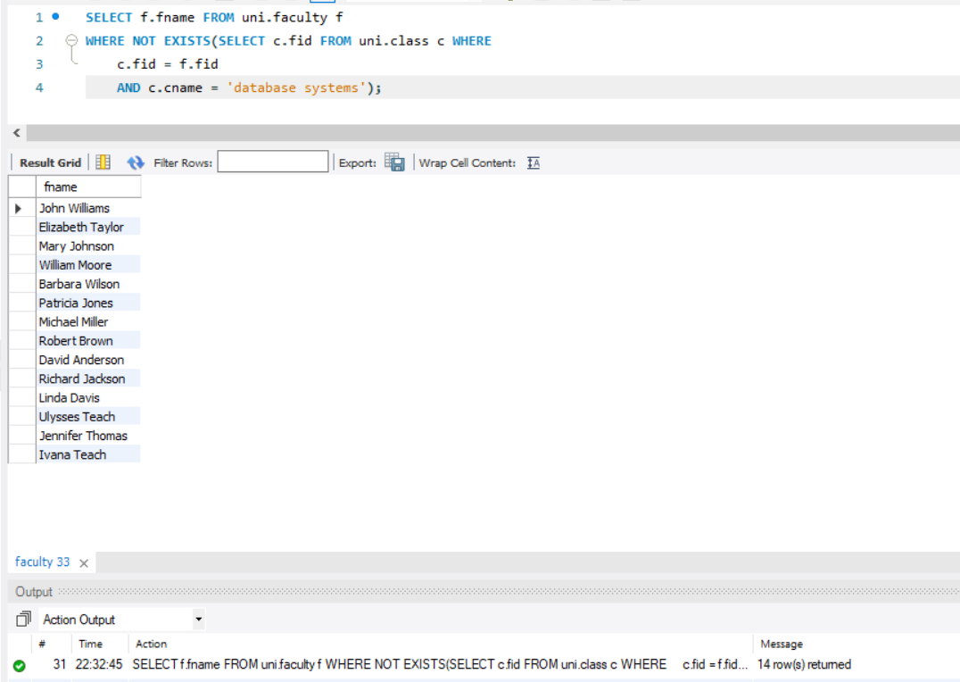

Find the name of faculty members who do not teach any course.

### Query:

SELECT f.fname FROM uni.faculty f

WHERE NOT EXISTS(SELECT c.fid FROM uni.class c

WHERE c.fid = f.fid);

### Output:

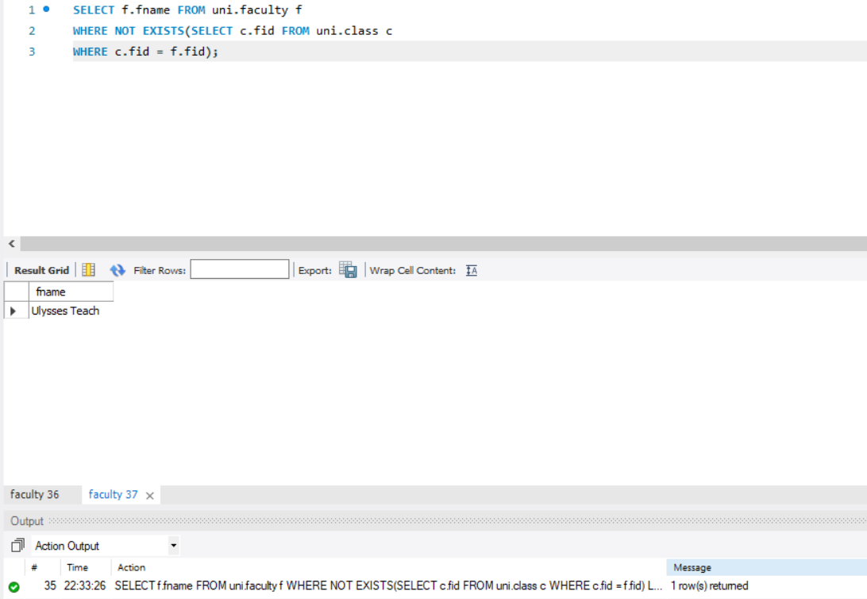

Find the name of faculty member, department who taught the maximum number of distinct classes.

### Query:

SELECT f.fid, fname, deptid, COUNT(cname) FROM uni.faculty f, uni.class c

WHERE c.fid = f.fid

GROUP BY f.fid

HAVING COUNT(cname) = (SELECT MAX(classCount) FROM

(SELECT COUNT(DISTINCT cname) AS classCount FROM uni.class cl, uni.faculty f2

WHERE cl.fid = f2.fid

GROUP BY cl.fid) AS M);

### Output:

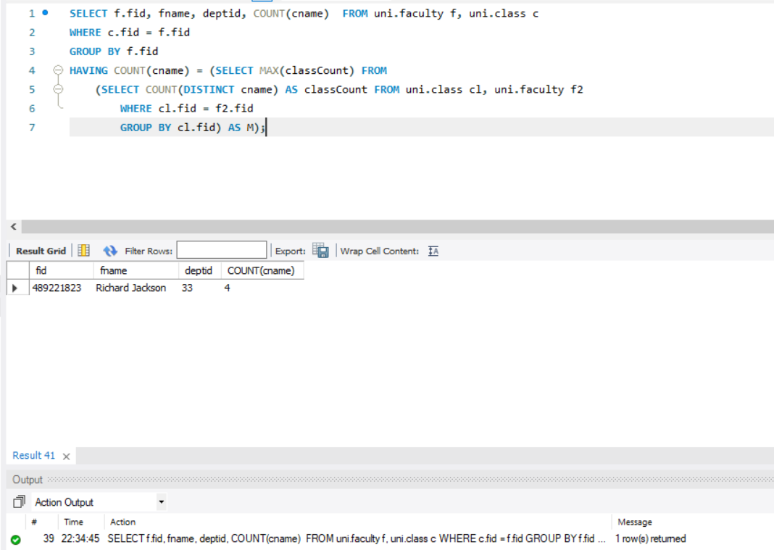

Find the names of all those classes and their enrollment strength that have maximum enrollment of students. (Not correlated nested query)

### Query:

SELECT cname, COUNT(cname) AS Strength FROM uni.enrollment e

GROUP BY cname

HAVING COUNT(cname) = (SELECT MAX(strength) FROM

(SELECT COUNT(DISTINCT e.snum) AS strength FROM uni.enrollment e

GROUP BY e.cname) AS M);

### Output:

